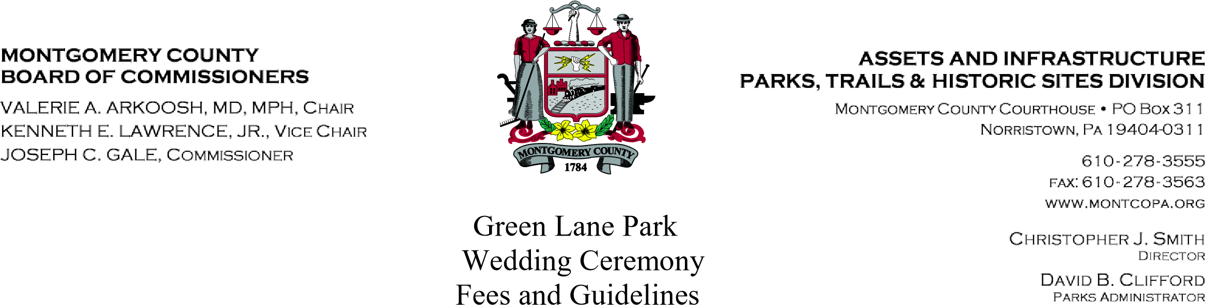
Ceremonies Only - (2 hours- No food/drink)
Mon. –Thurs. between 10am and 4pm 100.00 Fri., Sat, Sun. & Holidays between 10am and 4pm 200.00

- Application for permit must be submitted at least 90 days in advance.

- Prior to permit approval, couple must meet with the Park Manager to clarify the ceremony details.

- Ceremonies are permitted in one (1) location only:

The Deep Creek Lake Gazebo

- Maximum 75 persons. On-site parking lot for 50 cars. No parking on driveways or boat launch area.

- It is advisable to have an alternate site for the ceremony in case of inclement weather. The park picnic pavilion may be reserved for an additional fee, if available.

- Upon approval, folding chairs are permitted, but must be set up and taken down by rental company within the 2 hour permit period.

- Alcoholic beverages are not permitted.

- The volume of electronically produced music or announcements must be kept at a minimum level.

- Green Lane Park is a natural area. As a green venue with an ongoing effort in sustainability in all aspects of the site, we request no rice, birdseed, silk or paper petals, confetti, glitter, floating lanterns, fireworks or sparklers.

- The full rental fee is due within 2 weeks of the permit approval. In the event of cancellation, no monies collected will be refunded for any reason.

I have read the above policies and have reviewed the Green Lane Park rules and regulations. I, the undersigned, as sponsor of this wedding group, will be personally responsible for any violation of those rules and regulations.

___________________________________ ______________ ___________________
Signature Phone Date

Wedding Day, Date & Time ___________________________________________________

